AI-Based Multi-Constraint Delivery Route Optimizer
Priority-Aware, Disruption-Resilient Routing using Ant Colony Optimization
Final Year Project Proposal — B.Tech (Nature-Inspired Algorithm)

The Problem
Planning an efficient delivery route across multiple stops is a computationally expensive problem, and real-world delivery routing adds further complexity beyond simple distance minimization: vehicles have limited carrying capacity, customers expect delivery within specific time windows, not all deliveries carry equal urgency, and road conditions can change mid-route due to closures, accidents, or weather. A basic “shortest route” solver accounts for none of this, making it unrealistic for actual logistics use — and is also why a plain shortest-path implementation is a widely available, already-solved problem.

The Idea
A web application where a user enters delivery stops along with vehicle capacity, package weights, time windows, and a priority level for each delivery. The system uses Ant Colony Optimization (ACO) — a nature-inspired algorithm modeled on how ant colonies discover the shortest path to a food source — to find an efficient, valid route that respects these constraints while giving urgent deliveries appropriate precedence. The system can dynamically re-optimize routes in response to live road closures, and a Genetic Algorithm solves the same problem independently for comparison. A summary analytics dashboard reports the measurable benefit of optimization across completed deliveries.

How It Works, Step by Step
- User enters delivery stops, each with package weight, delivery time window, and a priority level (Critical, High, Normal, or Low), along with the vehicle's total carrying capacity
- The system builds a distance/time matrix between all stops
- An Ant Colony Optimization algorithm simulates multiple generations of virtual ants exploring possible routes, with each ant building a candidate route that respects capacity and time-window constraints while weighting the order of stops toward higher-priority deliveries
- Shorter, valid, priority-respecting routes are reinforced with stronger pheromone trails over successive iterations, guiding the colony toward better solutions
- If an admin marks a road as closed (due to construction, an accident, or flooding), the affected route segment is removed from the distance matrix and the algorithm re-optimizes the route live, without restarting from scratch
- The same routing problem is independently solved using a Genetic Algorithm, for comparison
- The system displays the optimized route on a map, a convergence graph comparing both algorithms, and an analytics dashboard summarizing results across completed deliveries

Core Technical Components

1. Capacitated, Time-Window-Aware Routing
The algorithm solves a Capacitated Vehicle Routing Problem with Time Windows (CVRPTW), a well-recognized, more advanced variant of the Traveling Salesman Problem. Routes must respect vehicle capacity limits and each customer's delivery time window. This constraint-checking logic is built directly into the cost/fitness function both algorithms optimize against, so an invalid route is penalized and effectively excluded from the final solution.

2. Delivery Priority Levels
Each delivery is assigned a priority level — Critical, High, Normal, or Low (for example, medical or perishable deliveries marked Critical). The cost/fitness function used by both algorithms is extended so that delaying a high-priority stop is penalized more heavily than delaying a low-priority one, meaning the optimizer balances overall route efficiency against getting urgent deliveries there sooner. This directly supports a disaster-relief or medical-delivery framing for the project, without requiring any new algorithmic machinery beyond adjusting the existing cost function.

3. Live Road Closure Simulation
An admin can mark a road segment as closed — simulating construction, an accident, or flooding. This removes or heavily penalizes the corresponding edge in the distance matrix, and the system re-runs the optimization to produce a new valid route on the fly. This demonstrates the algorithm's ability to adapt to disruptions dynamically, rather than only ever solving a static, unchanging problem — a capability worth highlighting live during a demonstration.

4. Ant Colony Optimization (Core Algorithm)
A from-scratch implementation of Ant Colony Optimization, in which simulated ants probabilistically choose the next stop based on pheromone trail strength and distance, weighted by delivery priority. Valid, efficient, priority-respecting routes are reinforced with additional pheromone, making them more likely to be chosen by future ants, mirroring how real ant colonies collectively discover efficient paths.

5. Genetic Algorithm (Comparison Algorithm)
A second, independent from-scratch implementation using a Genetic Algorithm, where a population of candidate routes evolves over generations through selection, crossover, and mutation. Solving the same problem with a structurally different algorithm allows for a genuine comparative study rather than a single, unverified implementation.

6. Convergence Visualization
The application displays how each algorithm's best-found solution improves over successive iterations/generations, making the optimization process transparent and demonstrating genuine understanding of how each algorithm behaves internally, including convergence speed and solution quality.

7. Delivery Analytics Dashboard
A summary dashboard reports metrics across completed deliveries: number of deliveries, average delivery time, success rate, and distance saved compared to an unoptimized baseline route. Since this dashboard summarizes data the system already computes during optimization (route distance, timing, and the naive-route comparison already used for the ACO vs. Genetic Algorithm study), it adds a polished, presentation-ready reporting layer without requiring new algorithmic work.

Where the Algorithm Is Actually Used
The core of the project consists of two from-scratch algorithm implementations — Ant Colony Optimization (nature-inspired, modeled on ant foraging behavior) and a Genetic Algorithm (modeled on natural selection) — both adapted to solve the same constrained, priority-weighted vehicle routing problem, with the ability to re-optimize when road closures are introduced. The map display, priority tagging, closure simulation, and analytics dashboard are supporting application logic built by the student around these two core algorithms; no external AI service or pre-built optimization library is required for the core routing logic itself.

Technologies Used
Layer | Technology
Backend | Python, Flask
Database | SQLite
Core Algorithm | Ant Colony Optimization (Python, from scratch)
Comparison Algorithm | Genetic Algorithm (Python, from scratch)
Map Display | Leaflet.js
Convergence Visualization | Chart.js
Analytics Dashboard | Chart.js, aggregated from stored delivery/route records
Frontend | HTML/CSS/JavaScript

Why This Project Goes Beyond an Existing Application
- Solves a Capacitated Vehicle Routing Problem with Time Windows and priority weighting, not a plain shortest-path search
- Dynamically re-optimizes routes in response to live disruptions (road closures), rather than only ever solving a static problem
- Includes a second, independently implemented algorithm (Genetic Algorithm) purely for comparison, adding analytical depth
- Visualizes the algorithm's internal convergence behavior, demonstrating understanding of how the algorithm works, not just that it works
- Produces a quantifiable results and analytics section (route quality, convergence speed, distance saved, success rate) for the final report, rather than a single demo output

Scope Notes
This project remains achievable within a final-year timeline by using a synthetic dataset for delivery stops, weights, time windows, priorities, and simulated road closures, rather than requiring integration with a real logistics provider or live traffic data. Priority weighting and road closure handling both extend the existing cost function and distance matrix already built for the core routing problem, rather than introducing separate subsystems — keeping the added scope manageable while meaningfully strengthening the project's technical depth and presentation value.

Application Screens
The following mockups illustrate the full user flow, including the newly added priority tagging, live road closure re-routing, and analytics dashboard.
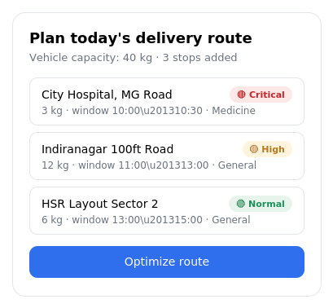
Screen 1 — Add delivery stops with weight, time window, and priority level
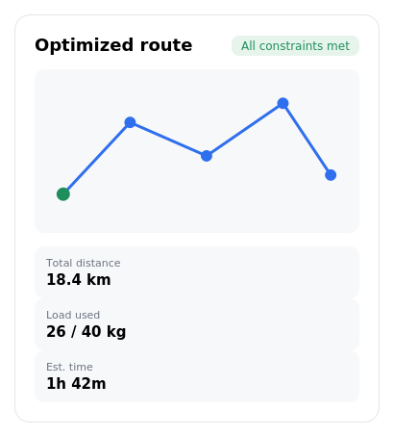
Screen 2 — Optimized route with distance, load, and time summary
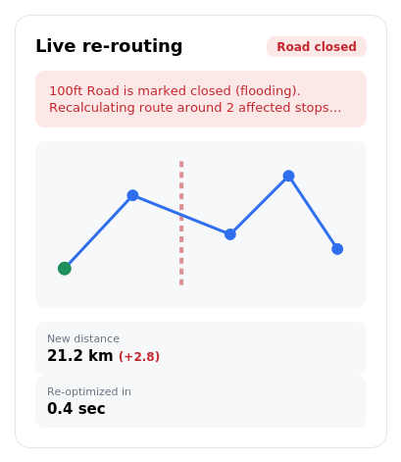
Screen 3 — Live re-routing after a road closure is marked
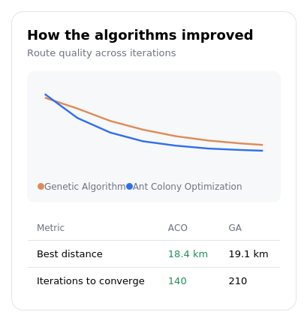
Screen 4 — Convergence graph and algorithm comparison (ACO vs. Genetic Algorithm)
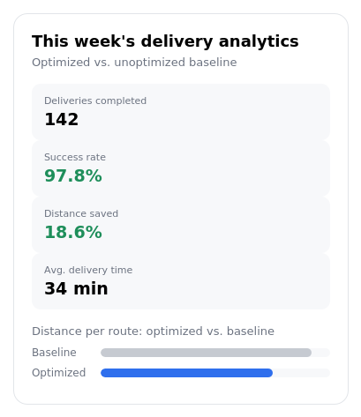
Screen 5 — Delivery analytics dashboard

